Iceland
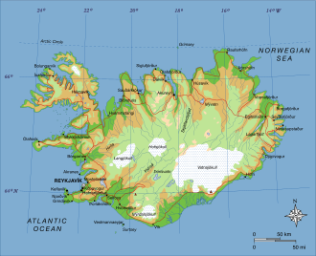
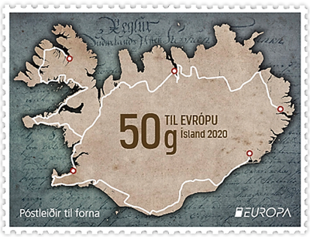
INCLUDEPICTURE "http://dic.academic.ru/pictures/wiki/files/83/StampIceland1930Michel136.jpg" \* MERGEFORMATINET INCLUDEPICTURE "http://dic.academic.ru/pictures/wiki/files/83/StampIceland1930Michel136.jpg" \* MERGEFORMATINET INCLUDEPICTURE "http://dic.academic.ru/pictures/wiki/files/83/StampIceland1930Michel136.jpg" \* MERGEFORMATINET INCLUDEPICTURE "http://dic.academic.ru/pictures/wiki/files/83/StampIceland1930Michel136.jpg" \* MERGEFORMATINET 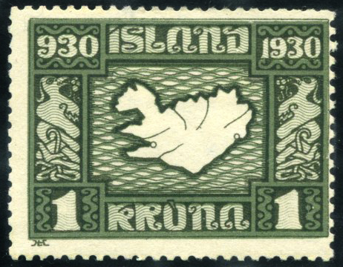 |  |  | 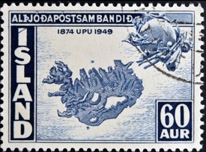
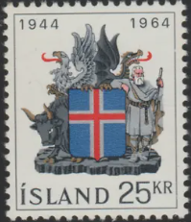
Chronology
c.7.. - c.8.. Celtic monks sail to Iceland.
c.860s First landings by the Norse in Iceland.
874 Traditional date for settlement from Norway
by Ingólfr Arnarson.
11 Jun 930 Commonwealth (republic), office of Lögsögumadhur
(Lawspeakers of the Althing) introduced.
Jun 999 (Catholic) Christianity formally adopted in Iceland.
Jun 1262 Union with Norway (as Jarldom [Earldom] of Iceland
to 1268).
12 Sep 1380 Danish rule over Norway (and dependencies including
Iceland) begins.
20 Jun 1627 - 19 Jul 1627 Pirates from the Barbary Coast attack the eastern,
southern coasts while based at Vestmannaeyjar.
20 Jan 1661 Direct Danish rule over Denmark.
6 Mar 1720 - 6 Mar 1775 Greenland and Faroe Islands (to 6 Sep 1775) are
subordinated to Iceland.
1783 - 1786 Volcanic activity destroys farmlands and leads
to widespread starvation.
1800 - 8 Mar 1843 Parliament (Althing) disbanded by royal decree
(restored by decree of 8 Mar 1843, convening on
1 Jul 1845).
26 Jun 1809 - 22 Aug 1809 Independence proclaimed by Danish adventurer
(Republic of Iceland).
22 Aug 1809 Danish rule restored (by convention).
24 Jan 1814 Recognized as a Danish possession by the Treaty
of Kiel following the end of union with Norway.
1 Jan 1849 Icelandic Department established (by royal
resolution of 28 Oct 1855)(under the Foreign
Ministry to 1 Nov 1855, then Justice Ministry).
5 Jan 1874 First Icelandic constitution granted by Denmark,
parliament established (effective 1 Aug 1874).
1 Aug 1874 Separate Icelandic Ministry created (by resolution
of 14 Jul 1874).
1 Feb 1904 Autonomy granted (by constitutional amendment of
3 Oct 1903).
1 Dec 1918 Kingdom of Iceland independent (in personal union
with Denmark).
10 Apr 1940 De facto end of personal union upon the German
occupation of Denmark.
10 May 1940 - 31 Dec 1945 Allied occupation (British from 22 Apr 1942 U.S.).
16 May 1941 Althing proclaiming Iceland's right to declare full
independence and not renew union with Denmark.
23 May 1944 Plebiscite endorses terminating the Danish personal
union by 99.5% and proclaiming a republic by
98.5%.
17 Jun 1944 Republic of Iceland
16 Jul 2009 Applies to join European Union, but suspended talks
13 Sep 2013, and withdrew application 12 Mar 2015.
Iceland
1380 Danish rule
26 Jun 1809 - 22 Aug 1809 independence proclaimed by Danish adventurer
1 Dec 1918 independence (kingdom in personal union with Denmark)
10 May 1940 - 1944 Allied occupation
17 Jun 1944 Republic of Iceland
Governors (to 1770 in Copenhagen)
1682 - 8 Dec 1719 Ulrik Christian Gyldenløve,
greve af Samsø (b. 1678 - d. 1719)
1719 - 29 Sep 1727 Peter Raben (b. 1661 - d. 1727)
1728 - 1730 Christian Gyldencrone (b. 1676 - d. 1746)
1730 - 9 Sep 1750 Henrik Ocksen (b. 1660 - d. 1750)
1750 - 2 Oct 1768 Otto Manderup, greve Rantzau (b. 1719 - d. 1768)
1768 - 1769 Christian Lebrecht, baron von
Prøck (b. 1718 - d. 1780)
1770 - 1785 Lauritz Andreas Thodal (b. 1718? - d. 1808)
1785 - 1789 Hans Christoph Diederich Victor
von Levetzow (b. 1754 - d. 1829)
1790 - 1806 Ólafur Stefánsson (b. 1731 - d. 1812)
1806 - 1810 Fredrik Christopher, greve af
Trampe (b. 1779 - d. 1832)
26 Jun 1809 - 22 Aug 1809 Jürgen Jürgensen (b. 1780 - d. 1841)
(de facto ruler; from 12 Jul 1809 styled "Protector")
1813 - 1819 Johan Carl Thuerecht Castenschiold (b. 1787 - d. 1844)
1819 - 1823 Ehrenreich Christopher Ludvig,
greve Moltke (b. 1790 - d. 1864)
1824 - 1829 Peter Fjeldsted Hoppe (b. 1794 - d. 1848)
1829 - 1836 Lorentz Angel Krieger (b. 1797 - d. 1837)
1837 - 1841 Carl Emil Bardenfleth (b. 1807 - d. 1857)
1841 - 1847 Torkild Abraham Hoppe (b. 1801 - d. 1871)
1847 - 1849 Mathias Hans Rosenørn (b. 1814 - d. 1902)
1850 - 1860 Jørgen Ditlev, greve Trampe (b. 1807 - d. 1868)
1860 - 8 May 1865 Thórdur Jónassen (b. 1800 - d. 1880)
8 May 1865 - 1883 Søren Hilmar Steindor Finsen (b. 1824 - d. 1886)
1883 - 1886 Bergur Ólafsson Thorberg (b. 1829 - d. 1886)
1886 - 1 Feb 1904 Magnús Stephensen (b. 1836 - d. 1917)
Ministers
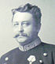 | 1 Feb 1904 - 31 Mar 1909 Hannes Hafstein (1st time)  (b. 1861 - d. 1922)
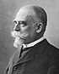 | 31 Mar 1909 - 14 Mar 1911 Björn Jónsson  (b. 1846 - d. 1912)
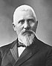 | 14 Mar 1911 - 24 Jul 1912 Kristján Jónsson  (b. 1852 - d. 1926)
 | 25 Jul 1912 - 21 Jul 1914 Hannes Hafstein (2nd time) (s.a.)
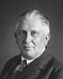 | 21 Jul 1914 - 4 May 1915 Sigurdur Eggerz  (b. 1875 - d. 1945)
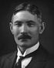 | 4 May 1915 - 4 Jan 1917 Einar Arnórsson  (b. 1880 - d. 1955)
King
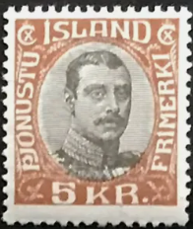 |  |  | 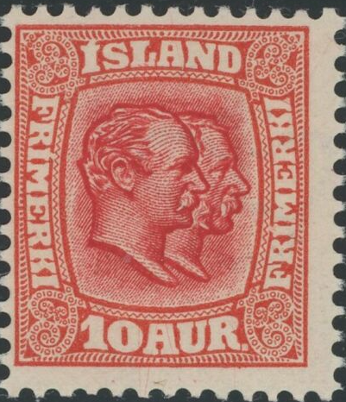
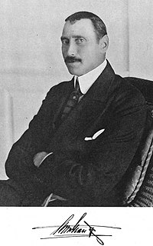 | 1 Dec 1918 - 16 Jun 1944 Christian X  (b. 1870 - d. 1947)
9 Apr 1940 - 17 Jun 1941 Regency
- Hermann Jónasson (b. 1896 - d. 1976)
- Jakob Möller (b. 1880 - d. 1955)
- Stefán Jóhann Stefánsson (b. 1894 - d. 1980)
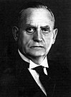 | 17 Jun 1941 - 16 Jun 1944 Sveinn Björnsson (regent)  (b. 1881 - d. 1952)
Commanders of the Allied occupation forces
10 May 1940 - Apr 1942 Henry O. Curtis (U.K.) (b. 1888 - d. 1964)
Apr 1942 - Jun 1943 Charles H. Bonesteel (U.S.) (b. 1885 - d. 1964)
Jun 1943 - Dec 1944 William S. Key (U.S.) (b. 1889 - d. 1959)
Valdas Adamkus
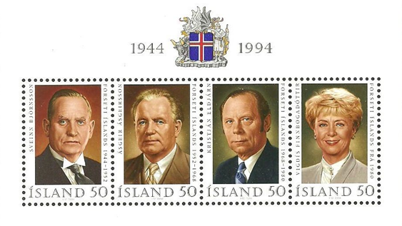
 | 17 Jun 1944 - 25 Jan 1952 Sveinn Björnsson (s.a.)
25 Jan 1952 - 31 Jul 1952 Interim triumvirate
- Steingrímur Steinthórsson (b. 1893 - d. 1966)
- Jón Pálmason (b. 1888 - d. 1973)
- Jón Ásbjörnsson (b. 1890 - d. 1966)
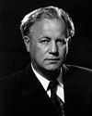 | 1 Aug 1952 - 31 Jul 1968 Ásgeir Ásgeirsson  (b. 1894 - d. 1972)
INCLUDEPICTURE "http://thumbs2.ebaystatic.com/d/l225/m/mSiyIBdDXt4ClQzDvC-v_lw.jpg" \* MERGEFORMATINET INCLUDEPICTURE "http://thumbs2.ebaystatic.com/d/l225/m/mSiyIBdDXt4ClQzDvC-v_lw.jpg" \* MERGEFORMATINET INCLUDEPICTURE "http://thumbs2.ebaystatic.com/d/l225/m/mSiyIBdDXt4ClQzDvC-v_lw.jpg" \* MERGEFORMATINET INCLUDEPICTURE "http://thumbs2.ebaystatic.com/d/l225/m/mSiyIBdDXt4ClQzDvC-v_lw.jpg" \* MERGEFORMATINET 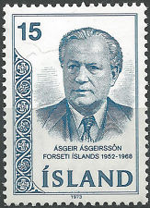 |  |  | INCLUDEPICTURE "http://i.ebayimg.com/00/s/MzI0WDIzOQ==/z/EL4AAMXQO21Rr2Yt/$(KGrHqNHJBMFBW)9BQeBBRr2YtSmzg~~60_12.JPG" \* MERGEFORMATINET INCLUDEPICTURE "http://i.ebayimg.com/00/s/MzI0WDIzOQ==/z/EL4AAMXQO21Rr2Yt/$(KGrHqNHJBMFBW)9BQeBBRr2YtSmzg~~60_12.JPG" \* MERGEFORMATINET INCLUDEPICTURE "http://i.ebayimg.com/00/s/MzI0WDIzOQ==/z/EL4AAMXQO21Rr2Yt/$(KGrHqNHJBMFBW)9BQeBBRr2YtSmzg~~60_12.JPG" \* MERGEFORMATINET INCLUDEPICTURE "http://i.ebayimg.com/00/s/MzI0WDIzOQ==/z/EL4AAMXQO21Rr2Yt/$(KGrHqNHJBMFBW)9BQeBBRr2YtSmzg~~60_12.JPG" \* MERGEFORMATINET 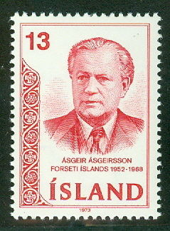
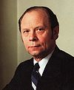 | 1 Aug 1968 - 31 Jul 1980 Kristján Eldjárn  (b. 1916 - d. 1982)
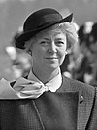 | 1 Aug 1980 - 31 Jul 1996 Vigdís Finnbogadóttir (f)  (b. 1930)
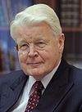 | 1 Aug 1996 - 31 Jul 2016 Ólafur Ragnar Grímsson  (b. 1943)
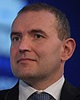 | 1 Aug 2016 - Gudni Jóhannesson  (b. 1968)
Prime ministers
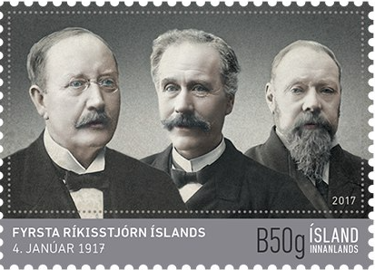
Новая почтовая марка Исландии. "100 лет со дня образования правительства". На марке изображены первые министры Исландии: Йон Магнуссон (премьер-министр и министр юстиции), Сигурдур Йонссон (министр труда) и Бьорн Кристьянссон (министр финансов).
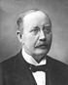 |  | 4 Jan 1917 - 7 Mar 1922 Jón Magnússon (1st time)  (b. 1859 - d. 1926)
 |  | 7 Mar 1922 - 22 Mar 1924 Sigurdur Eggerz (s.a.)
 |  | 22 Mar 1924 - 23 Jun 1926 Jón Magnússon (2nd time) (s.a.)
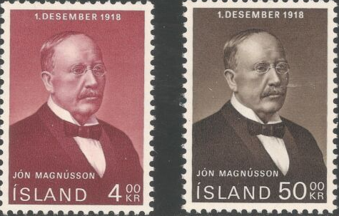
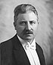 |  | 23 Jun 1926 - 8 Jul 1926 Magnús Gudmundsson  (b. 1879 - d. 1937)
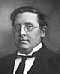 |  | 8 Jul 1926 - 28 Aug 1927 Jón Thorláksson  (b. 1877 - d. 1935)
28 Aug 1927 - 3 Jun 1932 Tryggvi Thórhallsson
(b. 1889 - d. 1935)
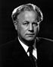 |  | 3 Jun 1932 - 29 Jul 1934 Ásgeir Ásgeirsson (s.a.)
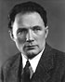 |  | 29 Jul 1934 - 16 May 1942 Hermann Jónasson (1st time) (s.a.)
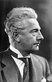 |  | 16 May 1942 - 16 Dec 1942 Ólafur Thors (1st time)  (b. 1892 - d. 1964)
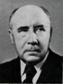 |  | 16 Dec 1942 - 21 Oct 1944 Björn Thórdarson  (b. 1879 - d. 1963)
Republic (1944–present)
 |  | 21 Oct 1944 - 4 Feb 1947 Ólafur Thors (2nd time) (s.a.)
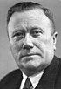 |  | 4 Feb 1947 - 6 Dec 1949 Stefán Jóhann Stefánsson (s.a.)
 |  | 6 Dec 1949 - 14 Mar 1950 Ólafur Thors (3rd time) (s.a.)
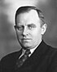 |  | 14 Mar 1950 - 11 Sep 1953 Steingrímur Steinthórsson (s.a.)
 |  | 11 Sep 1953 - 24 Jul 1956 Ólafur Thors (4th time) (s.a.)
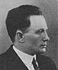 |  | 24 Jul 1956 - 23 Dec 1958 Hermann Jónasson (2nd time) (s.a.)
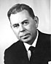 |  | 23 Dec 1958 - 20 Nov 1959 Emil Jónsson  (b. 1902 - d. 1986)
 |  | 20 Nov 1959 - 14 Nov 1963 Ólafur Thors (5th time) (s.a.)
14 Sep 1961 - 31 Dec 1961 Bjarni Benediktsson
(b. 1908 - d. 1970) (acting for Thors)
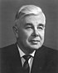 |  | 14 Nov 1963 - 10 Jul 1970 Bjarni Benediktsson (s.a.)
10 Jul 1970 - 14 Jul 1971 Jóhann Hafstein
(b. 1915 - d. 1980)
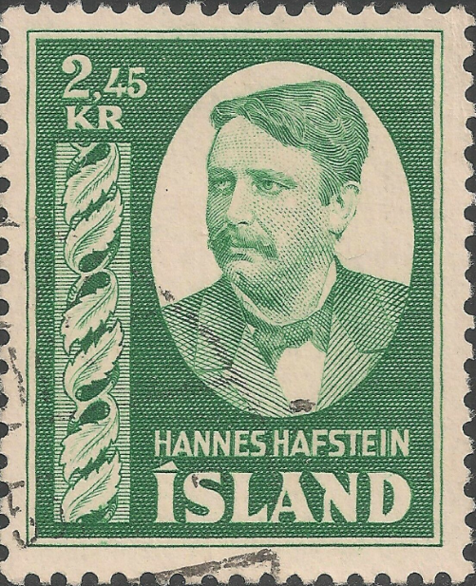
14 Jul 1971 - 28 Aug 1974 Ólafur Jóhannesson (1st time)
(b. 1913 - d. 1984)
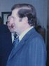 |  | 28 Aug 1974 - 1 Sep 1978 Geir Hallgrímsson  (b. 1925 - d. 1990)
1 Sep 1978 - 15 Oct 1979 Ólafur Jóhannesson
(2nd time) (s.a.)
15 Oct 1979 - 8 Feb 1980 Benedikt Gröndal
(b. 1924 - d. 2010)
8 Feb 1980 - 26 May 1983 Gunnar Thoroddsen
(b. 1910 - d. 1983)
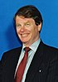 |  | 26 May 1983 - 8 Jul 1987 Steingrímur Hermannsson  (1st time) (b. 1928 - d. 2010)
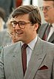 |  | 8 Jul 1987 - 28 Sep 1988 Thorsteinn Pálsson  (b. 1947)
28 Sep 1988 - 30 Apr 1991 Steingrímur Hermannsson
(2nd time) (s.a.)
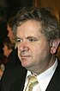 |  | 30 Apr 1991 - 15 Sep 2004 Davíd Oddsson  (b. 1948)
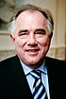 |  | 15 Sep 2004 - 15 Jun 2006 Halldór Ásgrímsson  (b. 1947 - d. 2015)
 |  | 15 Jun 2006 - 1 Feb 2009 Geir H. Haarde  (b. 1951)
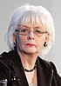 |  | 1 Feb 2009 - 23 May 2013 Jóhanna Sigurdardóttir (f)  (b. 1942)
 |  | 23 May 2013 - 7 Apr 2016 Sigmundur Davíd Gunnlaugsson  (b. 1975)
 |  | 7 Apr 2016 - 11 Jan 2017 Sigurdur Ingi Jóhannsson  (b. 1962)
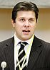 |  | 11 Jan 2017 - 30 Nov 2017 Bjarni Benediktsson  (b. 1970)
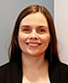 |  | 30 Nov 2017 - Katrín Jakobsdóttir (f)  (b. 1976)

Tryggvi Gunnarsson
Alþingismaður Norður-Þingeyinga 1869–1874 (sat ekki á þingi 1871 og 1873), alþingismaður Suður-Múlasýslu 1874–1885, alþingismaður Árnesinga 1894–1900, alþingismaður Reykvíkinga 1900–1908 (Heimastjórnarflokkurinn).
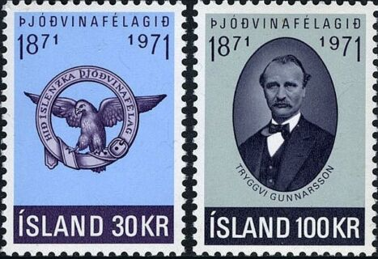
Emblem, Eagle. Tryggvi Gunnarsson, 1835-1917, founder and president...

INCLUDEPICTURE "http://t0.gstatic.com/images?q=tbn:ANd9GcTDT1jpfS6n_Y4NmsXFnf0dV2uAk854tEHeOSaIXPxUCt7qxHu5xaSaZA" \* MERGEFORMATINET INCLUDEPICTURE "http://t0.gstatic.com/images?q=tbn:ANd9GcTDT1jpfS6n_Y4NmsXFnf0dV2uAk854tEHeOSaIXPxUCt7qxHu5xaSaZA" \* MERGEFORMATINET INCLUDEPICTURE "http://t0.gstatic.com/images?q=tbn:ANd9GcTDT1jpfS6n_Y4NmsXFnf0dV2uAk854tEHeOSaIXPxUCt7qxHu5xaSaZA" \* MERGEFORMATINET INCLUDEPICTURE "http://t0.gstatic.com/images?q=tbn:ANd9GcTDT1jpfS6n_Y4NmsXFnf0dV2uAk854tEHeOSaIXPxUCt7qxHu5xaSaZA" \* MERGEFORMATINET INCLUDEPICTURE "http://t0.gstatic.com/images?q=tbn:ANd9GcTDT1jpfS6n_Y4NmsXFnf0dV2uAk854tEHeOSaIXPxUCt7qxHu5xaSaZA" \* MERGEFORMATINET INCLUDEPICTURE "http://t0.gstatic.com/images?q=tbn:ANd9GcTDT1jpfS6n_Y4NmsXFnf0dV2uAk854tEHeOSaIXPxUCt7qxHu5xaSaZA" \* MERGEFORMATINET INCLUDEPICTURE "http://t0.gstatic.com/images?q=tbn:ANd9GcTDT1jpfS6n_Y4NmsXFnf0dV2uAk854tEHeOSaIXPxUCt7qxHu5xaSaZA" \* MERGEFORMATINET INCLUDEPICTURE "http://t0.gstatic.com/images?q=tbn:ANd9GcTDT1jpfS6n_Y4NmsXFnf0dV2uAk854tEHeOSaIXPxUCt7qxHu5xaSaZA" \* MERGEFORMATINET INCLUDEPICTURE "http://t0.gstatic.com/images?q=tbn:ANd9GcTDT1jpfS6n_Y4NmsXFnf0dV2uAk854tEHeOSaIXPxUCt7qxHu5xaSaZA" \* MERGEFORMATINET INCLUDEPICTURE "http://t0.gstatic.com/images?q=tbn:ANd9GcTDT1jpfS6n_Y4NmsXFnf0dV2uAk854tEHeOSaIXPxUCt7qxHu5xaSaZA" \* MERGEFORMATINET INCLUDEPICTURE "http://t0.gstatic.com/images?q=tbn:ANd9GcTDT1jpfS6n_Y4NmsXFnf0dV2uAk854tEHeOSaIXPxUCt7qxHu5xaSaZA" \* MERGEFORMATINET INCLUDEPICTURE "http://t0.gstatic.com/images?q=tbn:ANd9GcTDT1jpfS6n_Y4NmsXFnf0dV2uAk854tEHeOSaIXPxUCt7qxHu5xaSaZA" \* MERGEFORMATINET INCLUDEPICTURE "http://t0.gstatic.com/images?q=tbn:ANd9GcTDT1jpfS6n_Y4NmsXFnf0dV2uAk854tEHeOSaIXPxUCt7qxHu5xaSaZA" \* MERGEFORMATINET INCLUDEPICTURE "http://t0.gstatic.com/images?q=tbn:ANd9GcTDT1jpfS6n_Y4NmsXFnf0dV2uAk854tEHeOSaIXPxUCt7qxHu5xaSaZA" \* MERGEFORMATINET INCLUDEPICTURE "http://t0.gstatic.com/images?q=tbn:ANd9GcTDT1jpfS6n_Y4NmsXFnf0dV2uAk854tEHeOSaIXPxUCt7qxHu5xaSaZA" \* MERGEFORMATINET INCLUDEPICTURE "http://t0.gstatic.com/images?q=tbn:ANd9GcTDT1jpfS6n_Y4NmsXFnf0dV2uAk854tEHeOSaIXPxUCt7qxHu5xaSaZA" \* MERGEFORMATINET INCLUDEPICTURE "http://t0.gstatic.com/images?q=tbn:ANd9GcTDT1jpfS6n_Y4NmsXFnf0dV2uAk854tEHeOSaIXPxUCt7qxHu5xaSaZA" \* MERGEFORMATINET INCLUDEPICTURE "http://t0.gstatic.com/images?q=tbn:ANd9GcTDT1jpfS6n_Y4NmsXFnf0dV2uAk854tEHeOSaIXPxUCt7qxHu5xaSaZA" \* MERGEFORMATINET INCLUDEPICTURE "http://t0.gstatic.com/images?q=tbn:ANd9GcTDT1jpfS6n_Y4NmsXFnf0dV2uAk854tEHeOSaIXPxUCt7qxHu5xaSaZA" \* MERGEFORMATINET INCLUDEPICTURE "http://t0.gstatic.com/images?q=tbn:ANd9GcTDT1jpfS6n_Y4NmsXFnf0dV2uAk854tEHeOSaIXPxUCt7qxHu5xaSaZA" \* MERGEFORMATINET INCLUDEPICTURE "http://t0.gstatic.com/images?q=tbn:ANd9GcTDT1jpfS6n_Y4NmsXFnf0dV2uAk854tEHeOSaIXPxUCt7qxHu5xaSaZA" \* MERGEFORMATINET INCLUDEPICTURE "http://t0.gstatic.com/images?q=tbn:ANd9GcTDT1jpfS6n_Y4NmsXFnf0dV2uAk854tEHeOSaIXPxUCt7qxHu5xaSaZA" \* MERGEFORMATINET INCLUDEPICTURE "http://t0.gstatic.com/images?q=tbn:ANd9GcTDT1jpfS6n_Y4NmsXFnf0dV2uAk854tEHeOSaIXPxUCt7qxHu5xaSaZA" \* MERGEFORMATINET INCLUDEPICTURE "http://t0.gstatic.com/images?q=tbn:ANd9GcTDT1jpfS6n_Y4NmsXFnf0dV2uAk854tEHeOSaIXPxUCt7qxHu5xaSaZA" \* MERGEFORMATINET INCLUDEPICTURE "http://t0.gstatic.com/images?q=tbn:ANd9GcTDT1jpfS6n_Y4NmsXFnf0dV2uAk854tEHeOSaIXPxUCt7qxHu5xaSaZA" \* MERGEFORMATINET INCLUDEPICTURE "http://t0.gstatic.com/images?q=tbn:ANd9GcTDT1jpfS6n_Y4NmsXFnf0dV2uAk854tEHeOSaIXPxUCt7qxHu5xaSaZA" \* MERGEFORMATINET INCLUDEPICTURE "http://t0.gstatic.com/images?q=tbn:ANd9GcTDT1jpfS6n_Y4NmsXFnf0dV2uAk854tEHeOSaIXPxUCt7qxHu5xaSaZA" \* MERGEFORMATINET INCLUDEPICTURE "http://t0.gstatic.com/images?q=tbn:ANd9GcTDT1jpfS6n_Y4NmsXFnf0dV2uAk854tEHeOSaIXPxUCt7qxHu5xaSaZA" \* MERGEFORMATINET INCLUDEPICTURE "http://t0.gstatic.com/images?q=tbn:ANd9GcTDT1jpfS6n_Y4NmsXFnf0dV2uAk854tEHeOSaIXPxUCt7qxHu5xaSaZA" \* MERGEFORMATINET INCLUDEPICTURE "http://t0.gstatic.com/images?q=tbn:ANd9GcTDT1jpfS6n_Y4NmsXFnf0dV2uAk854tEHeOSaIXPxUCt7qxHu5xaSaZA" \* MERGEFORMATINET INCLUDEPICTURE "http://t0.gstatic.com/images?q=tbn:ANd9GcTDT1jpfS6n_Y4NmsXFnf0dV2uAk854tEHeOSaIXPxUCt7qxHu5xaSaZA" \* MERGEFORMATINET INCLUDEPICTURE "http://t0.gstatic.com/images?q=tbn:ANd9GcTDT1jpfS6n_Y4NmsXFnf0dV2uAk854tEHeOSaIXPxUCt7qxHu5xaSaZA" \* MERGEFORMATINET INCLUDEPICTURE "http://t0.gstatic.com/images?q=tbn:ANd9GcTDT1jpfS6n_Y4NmsXFnf0dV2uAk854tEHeOSaIXPxUCt7qxHu5xaSaZA" \* MERGEFORMATINET INCLUDEPICTURE "http://t0.gstatic.com/images?q=tbn:ANd9GcTDT1jpfS6n_Y4NmsXFnf0dV2uAk854tEHeOSaIXPxUCt7qxHu5xaSaZA" \* MERGEFORMATINET INCLUDEPICTURE "http://t0.gstatic.com/images?q=tbn:ANd9GcTDT1jpfS6n_Y4NmsXFnf0dV2uAk854tEHeOSaIXPxUCt7qxHu5xaSaZA" \* MERGEFORMATINET INCLUDEPICTURE "http://t0.gstatic.com/images?q=tbn:ANd9GcTDT1jpfS6n_Y4NmsXFnf0dV2uAk854tEHeOSaIXPxUCt7qxHu5xaSaZA" \* MERGEFORMATINET INCLUDEPICTURE "http://t0.gstatic.com/images?q=tbn:ANd9GcTDT1jpfS6n_Y4NmsXFnf0dV2uAk854tEHeOSaIXPxUCt7qxHu5xaSaZA" \* MERGEFORMATINET INCLUDEPICTURE "http://t0.gstatic.com/images?q=tbn:ANd9GcTDT1jpfS6n_Y4NmsXFnf0dV2uAk854tEHeOSaIXPxUCt7qxHu5xaSaZA" \* MERGEFORMATINET INCLUDEPICTURE "http://t0.gstatic.com/images?q=tbn:ANd9GcTDT1jpfS6n_Y4NmsXFnf0dV2uAk854tEHeOSaIXPxUCt7qxHu5xaSaZA" \* MERGEFORMATINET INCLUDEPICTURE "http://t0.gstatic.com/images?q=tbn:ANd9GcTDT1jpfS6n_Y4NmsXFnf0dV2uAk854tEHeOSaIXPxUCt7qxHu5xaSaZA" \* MERGEFORMATINET INCLUDEPICTURE "http://t0.gstatic.com/images?q=tbn:ANd9GcTDT1jpfS6n_Y4NmsXFnf0dV2uAk854tEHeOSaIXPxUCt7qxHu5xaSaZA" \* MERGEFORMATINET INCLUDEPICTURE "http://t0.gstatic.com/images?q=tbn:ANd9GcTDT1jpfS6n_Y4NmsXFnf0dV2uAk854tEHeOSaIXPxUCt7qxHu5xaSaZA" \* MERGEFORMATINET INCLUDEPICTURE "http://t0.gstatic.com/images?q=tbn:ANd9GcTDT1jpfS6n_Y4NmsXFnf0dV2uAk854tEHeOSaIXPxUCt7qxHu5xaSaZA" \* MERGEFORMATINET INCLUDEPICTURE "http://t0.gstatic.com/images?q=tbn:ANd9GcTDT1jpfS6n_Y4NmsXFnf0dV2uAk854tEHeOSaIXPxUCt7qxHu5xaSaZA" \* MERGEFORMATINET INCLUDEPICTURE "http://t0.gstatic.com/images?q=tbn:ANd9GcTDT1jpfS6n_Y4NmsXFnf0dV2uAk854tEHeOSaIXPxUCt7qxHu5xaSaZA" \* MERGEFORMATINET INCLUDEPICTURE "http://t0.gstatic.com/images?q=tbn:ANd9GcTDT1jpfS6n_Y4NmsXFnf0dV2uAk854tEHeOSaIXPxUCt7qxHu5xaSaZA" \* MERGEFORMATINET INCLUDEPICTURE "http://t0.gstatic.com/images?q=tbn:ANd9GcTDT1jpfS6n_Y4NmsXFnf0dV2uAk854tEHeOSaIXPxUCt7qxHu5xaSaZA" \* MERGEFORMATINET INCLUDEPICTURE "http://t0.gstatic.com/images?q=tbn:ANd9GcTDT1jpfS6n_Y4NmsXFnf0dV2uAk854tEHeOSaIXPxUCt7qxHu5xaSaZA" \* MERGEFORMATINET INCLUDEPICTURE "http://t0.gstatic.com/images?q=tbn:ANd9GcTDT1jpfS6n_Y4NmsXFnf0dV2uAk854tEHeOSaIXPxUCt7qxHu5xaSaZA" \* MERGEFORMATINET INCLUDEPICTURE "http://t0.gstatic.com/images?q=tbn:ANd9GcTDT1jpfS6n_Y4NmsXFnf0dV2uAk854tEHeOSaIXPxUCt7qxHu5xaSaZA" \* MERGEFORMATINET INCLUDEPICTURE "http://t0.gstatic.com/images?q=tbn:ANd9GcTDT1jpfS6n_Y4NmsXFnf0dV2uAk854tEHeOSaIXPxUCt7qxHu5xaSaZA" \* MERGEFORMATINET INCLUDEPICTURE "http://t0.gstatic.com/images?q=tbn:ANd9GcTDT1jpfS6n_Y4NmsXFnf0dV2uAk854tEHeOSaIXPxUCt7qxHu5xaSaZA" \* MERGEFORMATINET INCLUDEPICTURE "http://t0.gstatic.com/images?q=tbn:ANd9GcTDT1jpfS6n_Y4NmsXFnf0dV2uAk854tEHeOSaIXPxUCt7qxHu5xaSaZA" \* MERGEFORMATINET INCLUDEPICTURE "http://t0.gstatic.com/images?q=tbn:ANd9GcTDT1jpfS6n_Y4NmsXFnf0dV2uAk854tEHeOSaIXPxUCt7qxHu5xaSaZA" \* MERGEFORMATINET INCLUDEPICTURE "http://t0.gstatic.com/images?q=tbn:ANd9GcTDT1jpfS6n_Y4NmsXFnf0dV2uAk854tEHeOSaIXPxUCt7qxHu5xaSaZA" \* MERGEFORMATINET INCLUDEPICTURE "http://t0.gstatic.com/images?q=tbn:ANd9GcTDT1jpfS6n_Y4NmsXFnf0dV2uAk854tEHeOSaIXPxUCt7qxHu5xaSaZA" \* MERGEFORMATINET INCLUDEPICTURE "http://t0.gstatic.com/images?q=tbn:ANd9GcTDT1jpfS6n_Y4NmsXFnf0dV2uAk854tEHeOSaIXPxUCt7qxHu5xaSaZA" \* MERGEFORMATINET INCLUDEPICTURE "http://t0.gstatic.com/images?q=tbn:ANd9GcTDT1jpfS6n_Y4NmsXFnf0dV2uAk854tEHeOSaIXPxUCt7qxHu5xaSaZA" \* MERGEFORMATINET INCLUDEPICTURE "http://t0.gstatic.com/images?q=tbn:ANd9GcTDT1jpfS6n_Y4NmsXFnf0dV2uAk854tEHeOSaIXPxUCt7qxHu5xaSaZA" \* MERGEFORMATINET INCLUDEPICTURE "http://t0.gstatic.com/images?q=tbn:ANd9GcTDT1jpfS6n_Y4NmsXFnf0dV2uAk854tEHeOSaIXPxUCt7qxHu5xaSaZA" \* MERGEFORMATINET INCLUDEPICTURE "http://t0.gstatic.com/images?q=tbn:ANd9GcTDT1jpfS6n_Y4NmsXFnf0dV2uAk854tEHeOSaIXPxUCt7qxHu5xaSaZA" \* MERGEFORMATINET INCLUDEPICTURE "http://t0.gstatic.com/images?q=tbn:ANd9GcTDT1jpfS6n_Y4NmsXFnf0dV2uAk854tEHeOSaIXPxUCt7qxHu5xaSaZA" \* MERGEFORMATINET INCLUDEPICTURE "http://t0.gstatic.com/images?q=tbn:ANd9GcTDT1jpfS6n_Y4NmsXFnf0dV2uAk854tEHeOSaIXPxUCt7qxHu5xaSaZA" \* MERGEFORMATINET INCLUDEPICTURE "http://t0.gstatic.com/images?q=tbn:ANd9GcTDT1jpfS6n_Y4NmsXFnf0dV2uAk854tEHeOSaIXPxUCt7qxHu5xaSaZA" \* MERGEFORMATINET INCLUDEPICTURE "http://t0.gstatic.com/images?q=tbn:ANd9GcTDT1jpfS6n_Y4NmsXFnf0dV2uAk854tEHeOSaIXPxUCt7qxHu5xaSaZA" \* MERGEFORMATINET INCLUDEPICTURE "http://t0.gstatic.com/images?q=tbn:ANd9GcTDT1jpfS6n_Y4NmsXFnf0dV2uAk854tEHeOSaIXPxUCt7qxHu5xaSaZA" \* MERGEFORMATINET INCLUDEPICTURE "http://t0.gstatic.com/images?q=tbn:ANd9GcTDT1jpfS6n_Y4NmsXFnf0dV2uAk854tEHeOSaIXPxUCt7qxHu5xaSaZA" \* MERGEFORMATINET

Compiler FLN

